

CBOE Financial Network

Network Specification

Version 4.0

October 1, 2009

OVERVIEW
The CBOE Financial Network (CFN) is disseminates multicast market data to CBOE Member Firms and Market Data Vendors. Different Market Data products are available via the CFN. The CFN is the only source for Current Quote / Last Sale (CQ/LS) information for the OneChicago Exchange (ONE) and for the CBOE Futures Exchange (CFE). Book Depth (BD) information for these two Exchanges are also available via the CFN.
CBOE, through its subsidiary, Market Data Express (MDX) offers a service comprised of various CBOE index values such as SPX, OEX, VIX, etc. This service is called Market Data Indices (MDI).

NETWORK DESIGN
The CFN uses IP multicast to efficiently and equitably distribute market data to all connected Firms simultaneously. Identical copies of the data are sent to different A and B multicast groups that follow diverse network paths so that a network outage cannot affect both sets of groups. Since there is no provision for retransmitting missed data, firms should read both A and B groups to fill in any gaps.
There are two ways for firms to connect to the CFN:
- Direct Connections
- CBOE Approved Extranet Service Provider
With Direct Connections firms are responsible for ordering and managing their own WAN circuits to CBOE as well as their routers on the CBOE premises. The source for both A and B groups is at the CBOE location in downtown Chicago. In the event of a disaster, only the A groups will be transmitted from CBOE’s Disaster Recovery (DR) site.
Figure 1 shows a Direct Connection.
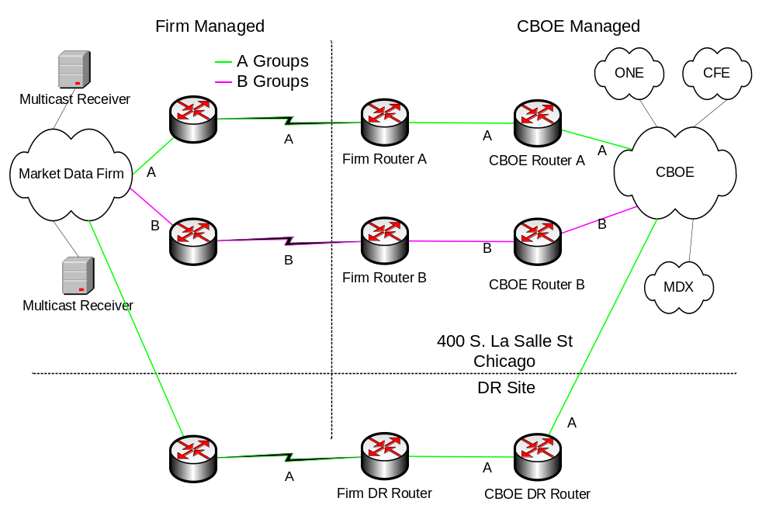
Figure 1: Direct Connection
The second type of CFN connection is via a CBOE approved Extranet Service Provider. Firms must first complete the CFN Connection Request form at the end of this document and return it to CBOE at cfn@cboe.com before ordering the connection through their Extranet Service Provider representative. Firms will be billed by CBOE for the data and by the Extranet Service Provider for the connectivity. For redundancy, the Firm must have two Extranet connections.
Figure 2 shows a sample Extranet Service Provider.
Note: Not all Extranet Service Providers have connections to the CBOE DR site.
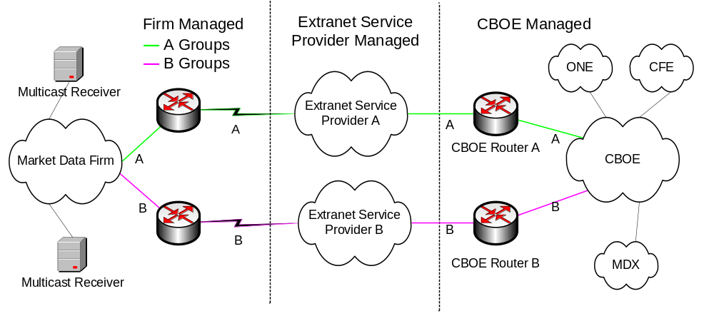
Figure 2: Extranet Service Provider
DATA CHANNEL INFORMATION
For each Data Channel, shown in Table 1 below, identical data is transmitted to two sets of multicast groups – A groups and B groups, with unique multicast group IP addresses and UDP port numbers. Bandwidth has been allocated to each Data Channel taking into consideration historical peak utilization and future growth.
The CFE and ONE Book Depth data channels use three multicast groups each. Products are distributed across the three groups alphabetically:
A-E - Multicast Group One
F-N - Multicast Group Two
O-Z - Multicast Group Three

Table 1: Data Channel Information
 |  |  | A Groups |  |  |  | B Groups
Data Channel | Bandwidth  Allocation |  | Multicast IP Address |  | UDP  Port |  | Multicast IP Address |  | UDP  Port
ONE CQ/LS | 9 Mbps |  | 233.65.120.1 |  | 52101 |  | 233.65.120.2 |  | 52102
ONE BD |  | 12 Mbps |  | 233.65.120.3 |  | 52103 |  | 233.65.120.4 |  | 52104
 |  |  |  | 233.65.120.5 |  | 52105 |  | 233.65.120.6 |  | 52106
 |  |  |  | 233.65.120.7 |  | 52107 |  | 233.65.120.8 |  | 52108
CFE CQ/LS | 450 Kbps |  | 233.65.120.16 |  | 52116 |  | 233.65.120.17 |  | 52117
CFE BD |  | 500 Kbps |  | 233.65.120.18 |  | 52118 |  | 233.65.120.19 |  | 52119
 |  |  |  | 233.65.120.20 |  | 52120 |  | 233.65.120.21 |  | 52121
 |  |  |  | 233.65.120.22 |  | 52122 |  | 233.65.120.23 |  | 52123
MDI | 50 Kbps |  | 233.65.120.32 |  | 52132 |  | 233.65.120.33 |  | 52133

MULTICAST CONFIGURATION
Direct Connections require the use of PIM Sparse Mode. Configurations with Extranet Service Provider may be different. Firms will need to add routes to the appropriate multicast source networks listed in Table 2. The Rendezvous Points (RP) for the Data Channels is shown in Table 3.
Table 2: Multicast Source Networks
Data Channel | Groups | Source Network
ONE CQ/LS | A | 170.137.92.0/24  170.137.100.0/28
ONE CQ/LS | B | 170.137.91.0/24
ONE BD | A | 170.137.13.96/28
ONE BD | B | 170.137.13.112/28
CFE CQ/LS | A | 170.137.92.0/24  170.137.100.0/28
CFE CQ/LS | B | 170.137.91.0/24
CFE BD | A | 170.137.13.96/28
CFE BD | B | 170.137.13.112/28
MDI | A | 170.137.13.96/28  170.137.100.0/28
MDI | B | 170.137.13.112/28

Table 3: Multicast Rendezvous Points
Product | Groups | Rendezvous Point
ONE, CFE, MDI | A | 170.137.255.97/32
ONE, CFE, MDI | B | 170.137.255.98/32

DATA FORMATS
The CFN does not process the market data or modify the data formats in any way. For information on the specific data formats please see these documents:
- CFE CQ/LS http://systems.cboe.com/webAPI/CFEMarketDataSpec.pdf
- CFE BD http://systems.cboe.com/webAPI/CFEBookDepthSpec.pdf
- ONE CQ/LS http://systems.cboe.com/webAPI/OneMarketDataSpec.pdf
- ONE BD http://systems.cboe.com/webAPI/OneBookDepthSpec.pdf
- MDI http://systems.cboe.com/webAPI/MarketDataIndexSpec.pdf

CONTACT INFORMATION
To report a problem on an existing CFN connection, please call the CBOE Operations Department at 312-786-7642.
For all other inquiries, please send an email to cfn@cboe.com.

CFN Connection Request Form

Requestor Information

Billing information
Firm Name: _________________________________________________
Address: _________________________________________________
City: _________________________________________________
State: _________________________________________________
Zip Code: _________________________________________________
Country: _________________________________________________
Firm Contact: _________________________________________________
Telephone: _________________________________________________
E-Mail Address: _________________________________________________

Initial here if you approve the applicable fees for this service.__________
Note: Service will not be activated if this is not initialed.

Requestor Contact (if different from above)
Name: _________________________________________________
Title: _________________________________________________
Telephone: _________________________________________________
Cell Phone / Pager: _________________________________________________
E-Mail Address: _________________________________________________

Data Channels (Add_____ Delete ______)

_____ CFE CQ/LS (inc. COF) _____ ONE CQ/LS

_____ CFE BD _____ ONE BD

_____ MDI

Type of Connection

_____ Direct Connection _____ Extranet Service Provider

Extranet Service Provider
Site A Information (A Groups)
Site Address
Street Address: ________________________________________________
City / State / Zip Code: ________________________________________________

Site Contact Information
Name: ________________________________________________
Title: ________________________________________________
Telephone: ________________________________________________
Cell Phone / Pager: ________________________________________________
E-Mail Address: ________________________________________________

Extranet Service Provider:___________________________________________________
Site B Information (B Groups)
Check if same as above _________

Site Address
Street Address: ________________________________________________
City / State / Zip Code: ________________________________________________

Site Contact Information
Name: ________________________________________________
Title: ________________________________________________
Telephone: ________________________________________________
Cell Phone / Pager: ________________________________________________
E-Mail Address: ________________________________________________
Extranet Service Provider (if different)_________________________________________

Direct Connect Information

Equipment Location #1: (Floor/Cabinet#)______________________________________

Equipment Location #2: (Floor/Cabinet#)______________________________________

